CN LAB

1. CONFIGURING OSPF PROTOCOL:

TOPOLOGY:

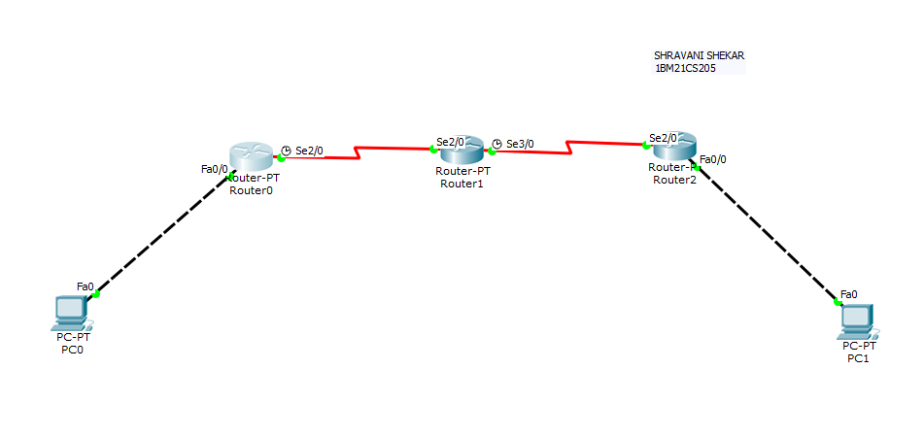

SHOW IP ROUTE -R1

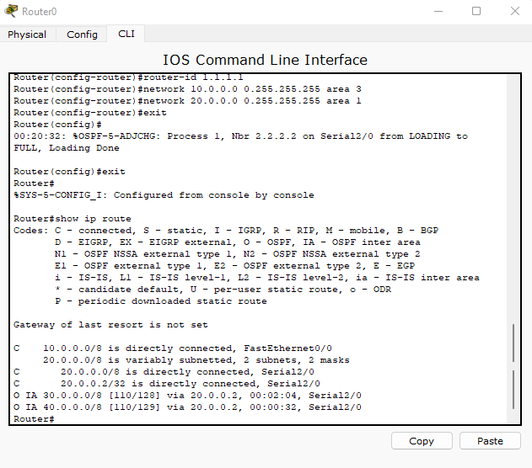

SHOW IP ROUTE-R3:

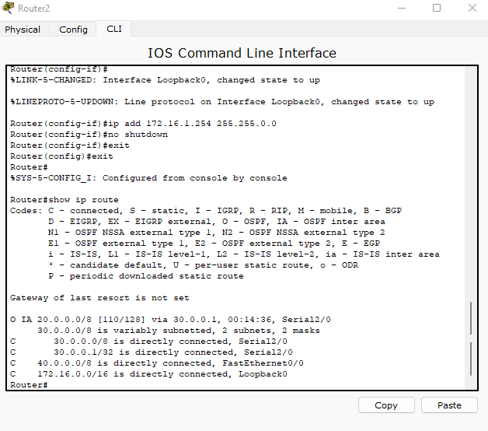

OUTPUT:

